Congratulations on your decision to enjoy the finest spas available

HOME OWNER PRE-DELIVERY INSTRUCTIONS

Please take the time to read these instructions carefully as they will provide you with the information you will need to ensure the safe, secure and timely installation of your new spa. The following sections are guidelines on how to prepare for the delivery and set-up of your new spa. Specifically covered are electrical requirements, site selection, ground preparation & delivery access.

If at any stage you are unsure of site preparation or delivery, please contact us for clarification.

REGULATIONS
- The covers on our brands of spa pools are lockable and regulations require that when not in use, spa pool covers must be in place and locked.
- The electrical connection to your spa pool is the responsibility of the owner and not us. We recommend that you consult with an experienced qualified electrician before delivery and all applicable electrical codes are followed.
  - We recommend a separate dedicated circuit for the spa pool with sizing and amperage dependent upon the brand, size and model of the spa (please ask us for details pertaining to your spa). This means that only the spa operates from that outlet. This prevents overloading of the circuit and subsequent tripping of circuit breakers and fuses
  - To make the delivery and installation process faster for the customer, it is a good idea if the customer has organised the electrical wiring requirements prior to delivery
  - Never run the spa on an extension cord
  - Please ask us for more details and/or consult your manual if in any doubt
  - Any damage that occurs to the spa as a result of incorrect electrical connection is not covered by warranty

SITE SELECTION & PREPARATION
- It is your responsibility to provide a suitable, level foundation for your spa. Please keep in mind that delivery crews are not equipped to level and prepare spa sites.
- Put your spa on a structurally sound, level surface. A filled spa can weigh a great deal especially when full of water and people. Make sure that the location you choose can support the weight. We can provide dimensions and weights of filled spas.
- If you are interested in having a concrete slab, brick surface or wood deck installed, Wright Pools and Spas may be able to suggest a qualified, licensed contractor. We recommend a 100mm thick reinforced concrete pad or timber deck built and structurally engineered by an appropriate licenced builder to enable support of the filled spa.
- Do not put your spa on a soft surface such as sand, loose soil or grass. Any surface that can settle unevenly (such as unsecured pavers or tiles) will put pressure and tension on the spa. This could eventually lead to distortion that would not be covered by warranty.

ALLOW SPACE AROUND THE SPA
We would recommend if using a concrete slab that it extends at least 200mm away from the spa edge to allow for stability. If using spa steps, you need to consider where these will be placed too.
- Optional cover lifting devices (CoverMate I, II or III) allow fingertip control of the opening and closing of the cover. The cover lifters are generally secured to the spa cabinet, opposite side to the control panel. If your spa is square, this does not have to be the case
  - As the cover lifter folds the cover down alongside the cabinet, allow 600mm clearance from obstacles such as a wall. If you have limited space, please consult us as we may be able to suggest a solution requiring less clearance.

INDOOR INSTALLATION
Be aware of some special requirements if you place your spa indoors. If water spills onto the floor around the spa it can cause poor footing. Flooring materials should give your feet good grip when wet and good drainage is essential. Water may also get into the woodwork and produce dry rot, mildew or other problems. The area's humidity will naturally be higher with the spa installed so check for airborne moisture's effects on exposed wood, paper etc. in the room. To minimise these effects and to make the room more comfortable it is best to provide plenty of ventilation to the spa area. An architect can help to determine if more ventilation must be installed. Additionally, when building a new room for the spa, install a floor drain to allow easy clean up of water and disposal of water when draining the spa.

DELIVERY ACCESS
- First, identify the dimensions of your spa from the brochure or website. Allow extra height for the height of the delivery cart or slider. We use a variety of trolleys depending on the situation. If in doubt we are happy to call around prior to delivery to view the access.
NOTE: It may be necessary to allow for additional overhead clearance if the spa is to go up or down stairs. If there are steps to be negotiated please advise us as we strongly suggest one of our delivery crew carries out a pre delivery site inspection.
- Please use the information in the drawings below to determine the feasibility of access. Keep in mind that the spa must remain on the delivery cart at all times. It may be necessary for you to remove a gate or partially dismantle a fence in order to provide an unobstructed passageway.
- Consider the width of doorways, gates and paths.
- Consider the height of the gutters, roof eaves, trees en -route to the spa location site
- Consider obstructions such as protruding pipes, drains, gas bottles, electrical boxes , bushes etc.
- Are there steep slopes or tight corners to negotiate? Remember spas do not bend!

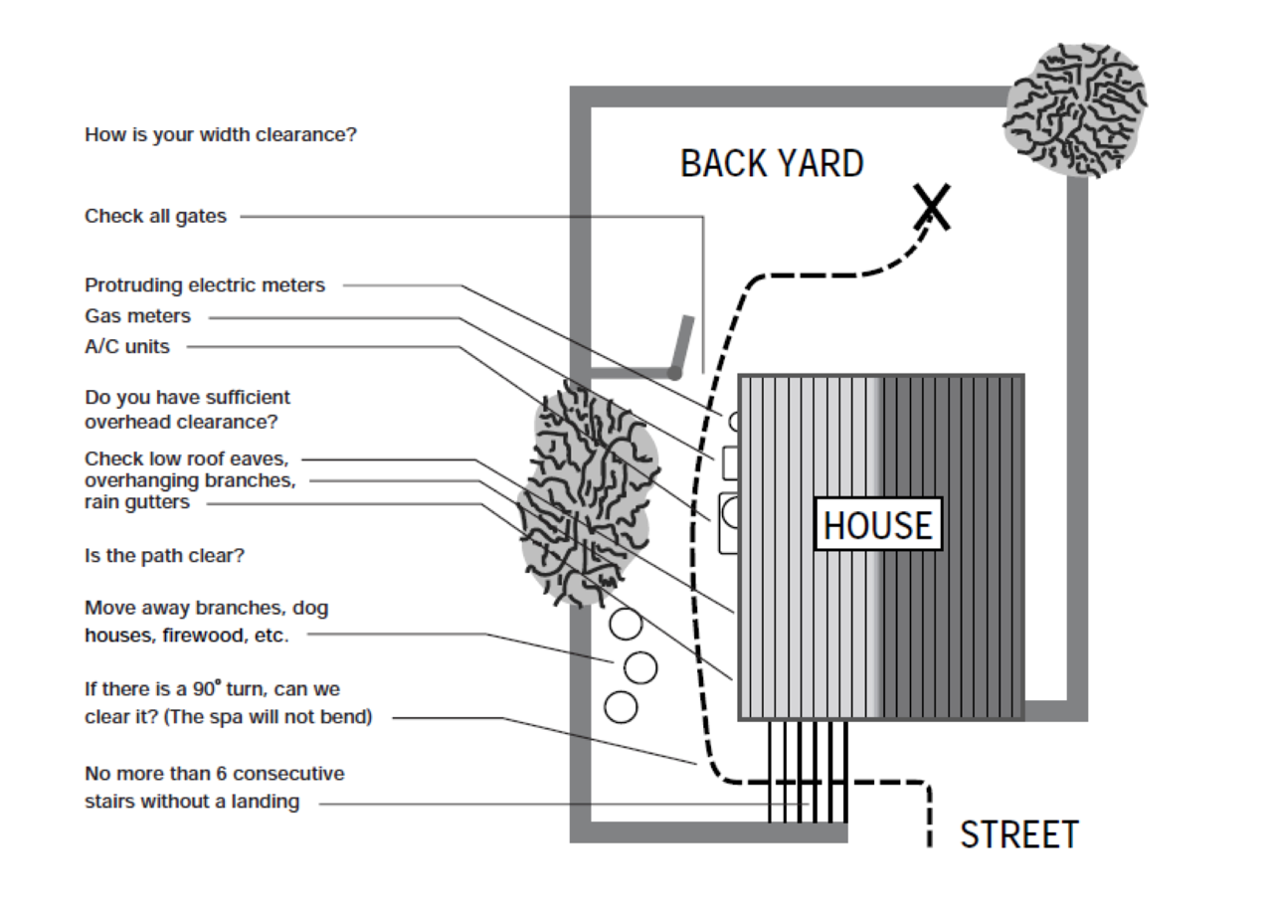

If the spa has to be taken off the cart to go over a wall (because the entry area is too narrow, the eaves are too low, the corner is too tight or the stairway is too steep), a crane may be required.
The use of a crane or hi-ab is a common delivery procedure that is necessary about 20% of the time. The crane has a truck-mounted boom that can fit right into your driveway. A licensed and insured operator runs it. For a fee, the crane operator will lift your spa over walls, buildings or any other obstruction and place it as close to the installation site as possible. The delivery personnel will assist with the crane delivery and placement of the spa in its final position. Crane delivery typically takes an average of 30 minutes to complete.

NOTE 1: If your spa delivery requires the use of a crane, you will be required to pay the cost of the crane or hi-ab
NOTE 2: Wright Pools and Spas will be responsible for the delivery of the spa to your property and will unload at a point considered by the delivery driver to be convenient and safe. However, it is your responsibility to provide access to the spa site and the cost of a crane or extra labour if required.

Be sure to check with us about your delivery details well before your spa is due to arrive.

Please remember that Wright Pools and Spas wish to make the delivery process as efficient as possible. We are always happy to call out to your site for a pre-delivery inspection within the greater Wellington area.

